
A CAMPUS LOST AND FOUND MANAGEMENT SYSTEM TO IMPROVE ITEM RECOVERY AND RECORD MANAGEMENT AT ZETECH UNIVERSITY

SYSTEM DOCUMENTATION

SUBMITTED BY,
CLEMENT WANYONYI
DIT-01-0065/2025

A SYSTEM DOCUMENTATION SUBMITTED IN PARTIAL FULFILMENT FOR THE AWARD OF DIPLOMA IN INFORMATION TECHNOLOGY BY ZETECH UNIVERSITY

APRIL 2026

DECLARATION

I declare that this project is my original work and has not been submitted to any other institution for academic credit. All sources of information used have been duly acknowledged.
Signature: ______________________
Date: ______________________
Name: Clement Wanyonyi
Admission Number: DIT-01-0065/2025

DEDICATION

This project is dedicated to my family and friends for their continuous support and encouragement throughout my academic journey. I also dedicate it to my lecturers for their guidance and inspiration.

ABSTRACT

This project presents the design and implementation of a Campus Lost and Found Management System aimed at improving item recovery and record management at Zetech University. The current lost and found process at Zetech University lacks a standardized verification mechanism to confirm rightful ownership before items are released, increasing the risk of disputes and fraudulent claims. The developed system provides a centralized platform where users can report lost and found items, track item status, and receive notifications when matches are identified. The system enhances accountability through proper record keeping and improves efficiency by automating key processes. The system was developed using HTML and CSS for the user interface, PHP for backend logic, and MySQL for database management. Testing confirmed that the system meets its objectives by improving accuracy, reducing delays, and enhancing user satisfaction. The project demonstrates how digital solutions can improve service delivery in institutional environments.

DEFINITION OF KEY TERMS

Lost Item – An item reported missing by a user.
Found Item – An item recovered and submitted to the system.
Database – A structured collection of stored data.
User – Any individual interacting with the system.
Administrator – A user with full system control and management rights.
Notification – A message alerting users about item status updates.

ABBREVIATIONS AND ACRONYMS

UI – User Interface
DB – Database
HTML – HyperText Markup Language
CSS – Cascading Style Sheets
SQL – Structured Query Language
PHP – Hypertext Preprocessor

LIST OF FIGURES

LIST OF TABLES

TABLE OF CONTENTS
Contents
CHAPTER ONE: PROJECT PLANNING AND ANALYSIS (WORKPLAN) 1
1.1 Statement of Problem 1
1.2 Study Justification 2
1.3 System Objectives 3
1.3.1 General Objective 3
1.3.2 Specific Objectives 3
1.4 Functional Requirements 3
Table 1.4 Functional Requirements Table 3
1.5 Breakdown of Tools & Resources 4
1. Software Tools 4
2. Development Environment 4
3. Deployment Resources 4
4. Hardware Resources 4
5. Human Resources 4
1.6 Project Schedule Breakdown 5
CHAPTER TWO: DESIGN AND MODELING 6
2.1 Introduction to Modelling 6
2.2 User Interface Models 6
2.2.1 Login Page 7
2.2.2 Sign-Up Form Design 8
Figure 2.2.2: Sign-Up Form Design 8
2.2.3 Dashboard Form Design 9
2.2.4 Lost and Found Records Management Page Design 10
2.3 Logic Models 11
2.3.1 Login Page Flowchart 12
2.3.2 Sign-Up Page Flowchart 13
2.3.3 Dashboard Page Flowchart 15
2.3.4 Records Management Flowchart 16
CHAPTER THREE: SYSTEM IMPLEMENTATION 17
(DEVELOPMENT, TESTING AND DEPLOYMENT) 17
3.1 Introduction 17
3.2 User Interface Development 17
3.2.1 Login Page Development 18
3.2.4 Dashboard Development 20
3.3 Logic Development 24
3.3.1 Database Implementation 25
3.3.2 Login Validation and Role Management 27
3.4 Testing 29
3.5 Deployment 30
CHAPTER FOUR: CONCLUSION AND RECOMMENDATION 31
4.1 Conclusion 31
4.2 Recommendation 32
REFERENCES 33

CHAPTER ONE: PROJECT PLANNING AND ANALYSIS (WORKPLAN)

1.1 Statement of Problem
The current lost and found process at Zetech University lacks a standardized verification mechanism to confirm rightful ownership before items are released, increasing the risk of disputes and fraudulent claims (Kariuki & Mugo, 2023). There is no integrated notification system to promptly alert students and staff when items matching their descriptions are recovered, which delays reunification and reduces the chances of successful claims (Otieno, 2022). The absence of clear data protection guidelines in handling personal information related to lost items exposes the institution to potential privacy breaches and potential non-compliance with modern data protection standards (Wambui & Njoroge, 2024). Limited transparency in tracking item status creates uncertainty among claimants, as they cannot monitor whether their report is being processed or reviewed (Mutua, 2023). Furthermore, the system does not generate analytical reports to identify trends such as frequently lost item categories or high-risk locations, which restricts the university’s ability to implement preventive measures (Kamau, 2022). The lack of a feedback mechanism also prevents users from reporting dissatisfaction or suggesting improvements, weakening continuous service enhancement efforts (Achieng, 2024). As a result, inefficiencies persist, accountability remains unclear, and overall user confidence in the lost and found service continues to decline (Mwangi & Oduor, 2023).

1.2 Study Justification

The implementation of a Campus Lost and Found Management System is justified because it provides a sustainable and efficient solution to the recurring problem of misplaced items within the university. Currently, the manual approach used by the lost and found office is tedious, unreliable, and inefficient. An automated system will streamline operations, reduce human error, and save time for both staff and students. It will ensure that all lost items are properly recorded, categorized, and retrievable through a user-friendly interface.
The system will also enhance communication by automatically notifying users when their items are found. Furthermore, digitization promotes accountability and transparency, as all transactions are stored in a secure database that can be audited when necessary. From a technological standpoint, this project aligns with the university’s goal of embracing digital transformation and modernizing administrative processes. Beyond efficiency, the system will foster trust between students and administrators, knowing that lost items are handled in a transparent and structured manner. Therefore, the proposed system is a necessary innovation to improve service delivery, accountability, and satisfaction among all campus stakeholders.

1.3 System Objectives

1.3.1 General Objective
- To develop a computerized campus lost and found management system for efficient tracking and recovery of items at Zetech University.

1.3.2 Specific Objectives

- To implement a system for reporting lost and found items.
- To develop a feature for storing and managing item records.
- To implement a notification system to alert users when items are found.
- To provide a tracking feature for monitoring item status.

1.4 Functional Requirements

User | User Activities | Features
Student | Log in to system | Secure login system
 | Report lost/found items | Item reporting interface
 | View item status | Database retrieval system
Administrator | Manage users | User management system
 | Manage item records | CRUD operations (Add/Edit/Delete)
 | Monitor system | Reports and dashboard
Security Staff | Verify items | Authentication system
 | Control access | Role-based access control

Table 1.4 Functional Requirements Table

1.5 Breakdown of Tools & Resources

1. Software Tools

- Front-End: HTML, CSS,
- Back-End: SQL
- Security: HTTPS

2. Development Environment

- IDE: Visual Studio Code
- Version Control: Git & GitHub

3. Deployment Resources

- Netlify: Free hosting for frontend HTML, CSS.
- GitHub Pages: Alternative free frontend hosting linked to GitHub repository.

4. Hardware Resources

- Client Devices: Computers and smartphones.
- Server Machine: Local PC or free-tier cloud server.

5. Human Resources

- System Developer: Designs, codes, and documents the system.
- Test Users: Classmates/friends for usability testing.
- Supervisor: Guides and evaluates the project.

1.6 Project Schedule Breakdown
 | PROJECT MILESTONES
WEEKS | Project Planning & Analysis  (System Documentation: Cover page & Chapter One) | Project Design & Modeling  (System Documentation Chapter Two) | Project Development & Testing  (System Documentation Chapter Three) | Project Deployment  (System Documentation Chapter Three) | Final Touches of System Documentation  (Preliminary Pages, Chapter Four & References) | Project Presentation
7-9 Jan
12-16 Jan
19-23 Jan
26-30 Jan
2-6 Feb
9-13 Feb
16-20 Feb
23-27 Feb
2-6 Mar
9-13 Mar
16-20 Mar
23-27 Mar
3rd April
Table 1.6 Project Schedule Breakdown

CHAPTER TWO: DESIGN AND MODELING

2.1 Introduction to Modelling

This chapter presents the design and modelling of the proposed Lost and Found Management System. The purpose of system modelling is to provide a visual representation of how the system will function before development begins. Various models such as user interface designs and flowcharts were used to illustrate system functionality and user interaction. These models helped in identifying potential design issues early, improving system usability, and ensuring that all system requirements were met before implementation. Overall, modelling provided a clear blueprint that guided the development process and reduced potential risks.

2.2 User Interface Models
This section presents the user interface (UI) models designed to show how different users interact with the lost and found management system. The interfaces were initially hand-sketched and later refined using drawing tools and shapes in Microsoft Word. These UI models guided the development of a user-friendly, consistent and interactive system.

2.2.1 Login Page

The login page is designed to allow registered users, such as students, staff, and administrators, to securely access the Lost and Found Management System. The interface includes input fields for the user’s registration number or username and password, as well as a login button. The simple layout ensures quick and easy access while maintaining system security.

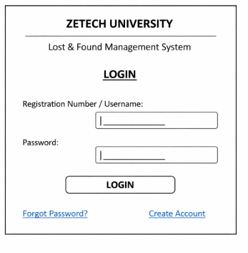
Figure 2.2.1: Login Page Design

2.2.2 Sign-Up Form Design

The sign-up form enables new users to create accounts within the Lost and Found Management System. It captures essential user details such as registration number, full name, course or department, contact information, and login credentials. User role selection ensures that appropriate access rights are assigned, such as student or administrator. Validation is considered at the design stage to ensure data accuracy and system security, preventing invalid or duplicate registrations.

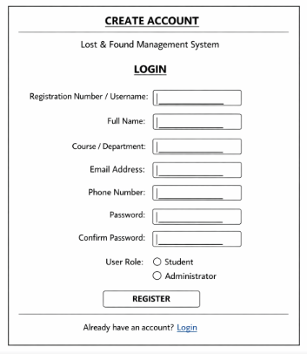

Figure 2.2.2: Sign-Up Form Design

2.2.3 Dashboard Form Design

The dashboard form provides users with an overview of system activities after successful login. It displays important information such as recently reported lost items, found items, notifications, and quick access links to key system functions. This design improves usability by allowing users to navigate the system efficiently from a single screen.

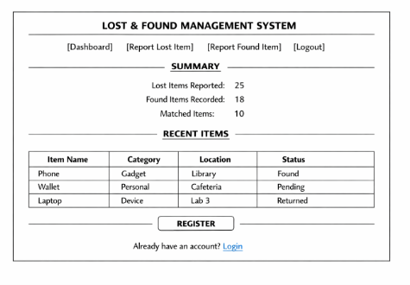
Figure 2.2.3: Dashboard Form Design

2.2.4 Lost and Found Records Management Page Design

The records management page allows administrators and authorized staff to manage lost and found item records within the system. It provides tools for adding new lost or found items, viewing item details, updating item status, deleting records, and searching for specific items.
Information is displayed in a tabular format for clarity, while action buttons enable efficient and accurate record management. This design supports proper tracking, accountability, and secure handling of lost and found items at Zetech University.

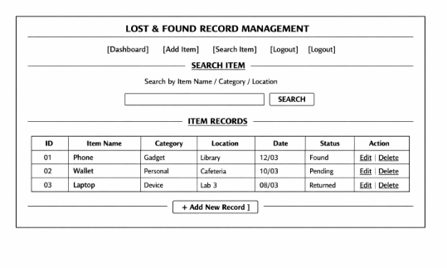Figure 2.2.4: Lost and Found Records Management Page Design

2.3 Logic Models

This section presents logic models that describe how data flows and processes are handled within the Lost and Found Management System. Flowcharts are used to illustrate system processes and decision-making steps clearly.

2.3.1 Login Page Flowchart

The login page flowchart illustrates the steps followed when a user attempts to access the system. The process begins when the user enters login credentials. The system validates the credentials against stored records. If the credentials are valid, access is granted and the user is redirected to the dashboard. If invalid, access is denied and the user is prompted to try again.

start

Enter credentials

Validate
Credentials]

Go to Dashboard

END

Display Invalid

NO

YES

Figure 2.3.1: Login page flowchart

2.3.2 Sign-Up Page Flowchart

The sign-up page flowchart shows the process followed when a new user registers in the system. The user enters the required details, which are then validated by the system. If the information is valid, the details are saved in the database and the account is successfully created. If the information is invalid, registration is denied and the user is prompted to correct the errors.

Enter Registration

Validate Input

Save to Database

S
how Error Message

END

Show Success & Redirect
to Login Page

START

NO

YES

Figure 2.3.2: signup page Flowchart

2.3.3 Dashboard Page Flowchart

This flowchart illustrates how the dashboard operates after a user successfully logs into the system. The dashboard displays different options such as reporting a lost item, viewing found items, checking item status, and managing records.

START

Dashboard Displayed

Select Action

Lost
Item

Found

Item

View
Item

Admin
records

Perform Selected Action

Log out

End

Figure 2.3.3: Dashboard page Flowchart

2.3.4 Records Management Flowchart

Select Action

add

view

update
te

delete

Perform Selected Action

Return to the
Dashboard

START

yes

yes

yes

yes

no

end

CHAPTER THREE: SYSTEM IMPLEMENTATION

(DEVELOPMENT, TESTING AND DEPLOYMENT)

3.1 Introduction

This chapter describes the implementation of the Zetech University Lost and Found Management System. It explains how the system was developed from the design models into a functional web application. The chapter also covers the development of user interfaces using HTML and CSS, the implementation of backend logic using PHP, and the configuration of the MySQL database. In addition, system testing and deployment procedures are discussed.

3.2 User Interface Development

The user interface was developed using HTML5 to structure the web pages and CSS3 to style and format the layout. These technologies ensured that the system interface is simple, responsive, and consistent with the branding of Zetech University.

3.2.1 Login Page Development
The login page serves as the secure entry point for all users. It features a clean layout with fields for a Registration Number and Password

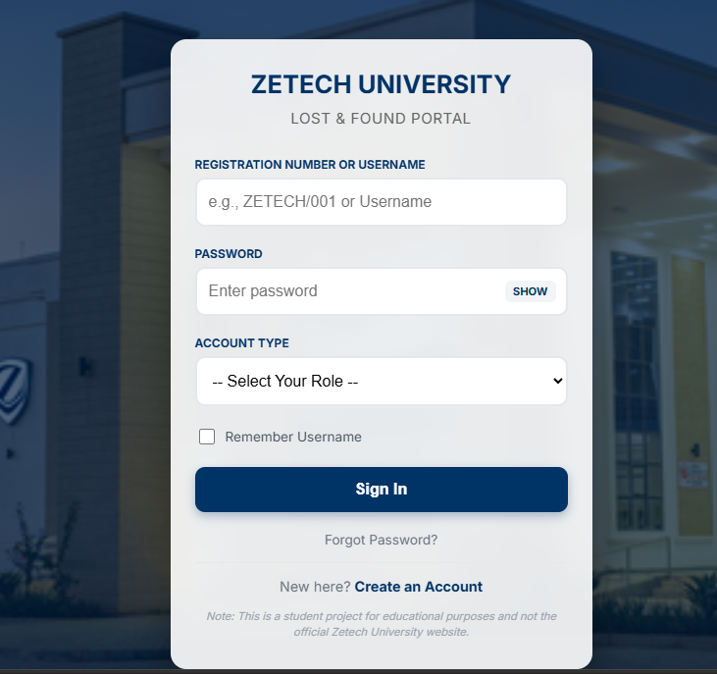
Figure 3.2.1 Login page screenshot
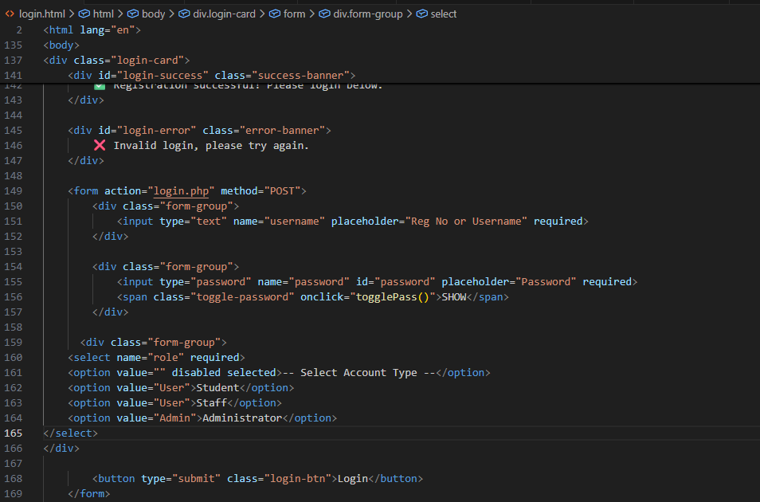Figure 3.2.2: HTML/CSS of login page screenshot
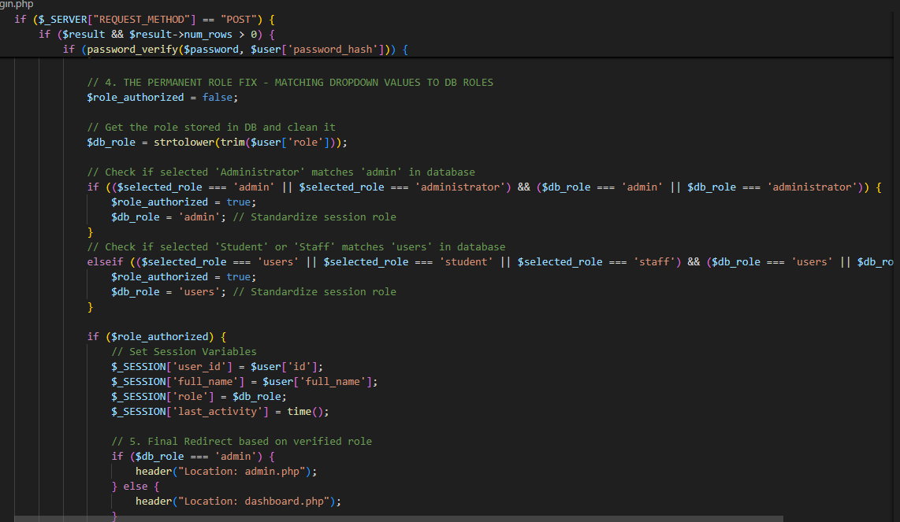Figure 3.2.3: login page php(backend) screenshot

3.2.4 Dashboard Development
The dashboard provides a central hub for users to view statistics on lost and found items and access reporting forms.

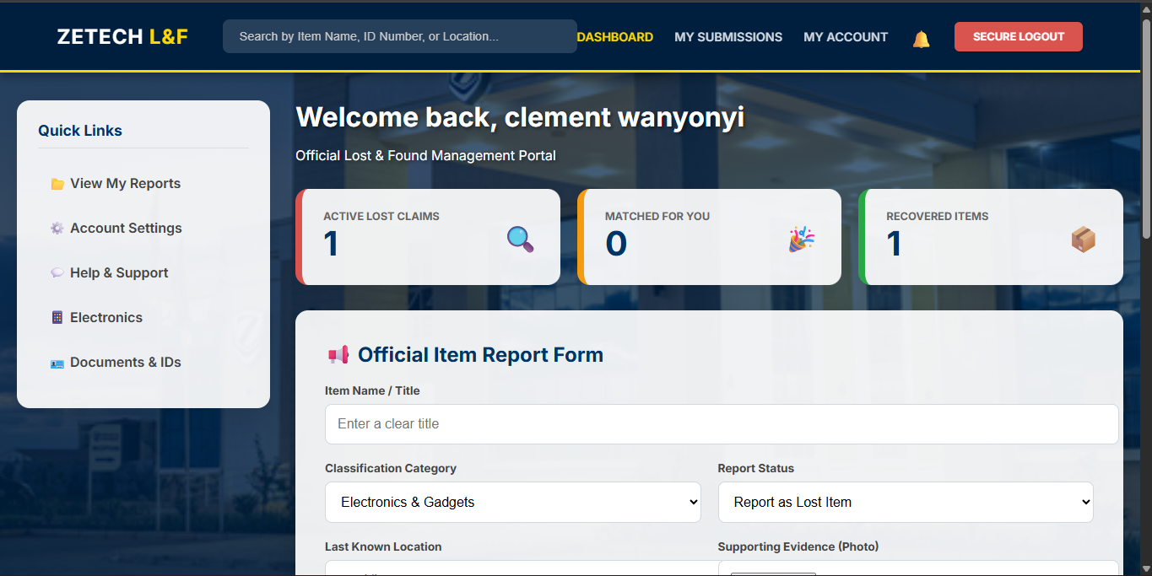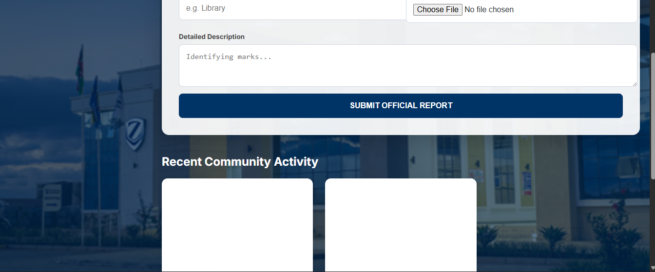
Figure 3.2.4: Dashboard page screenshot

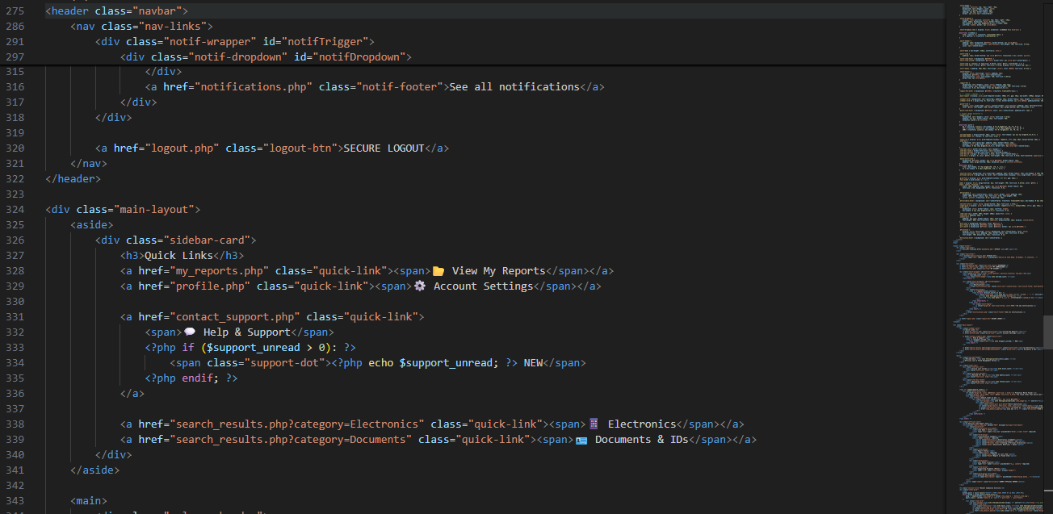 Figure 3.2.5 Dashboard HTML/CSS screenshot

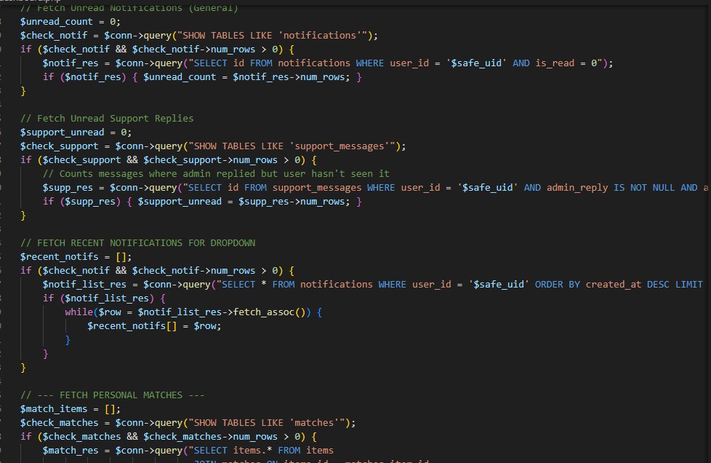Figure 3.2.6 Dashboard php screenshot

3.2.7 Signup page Development
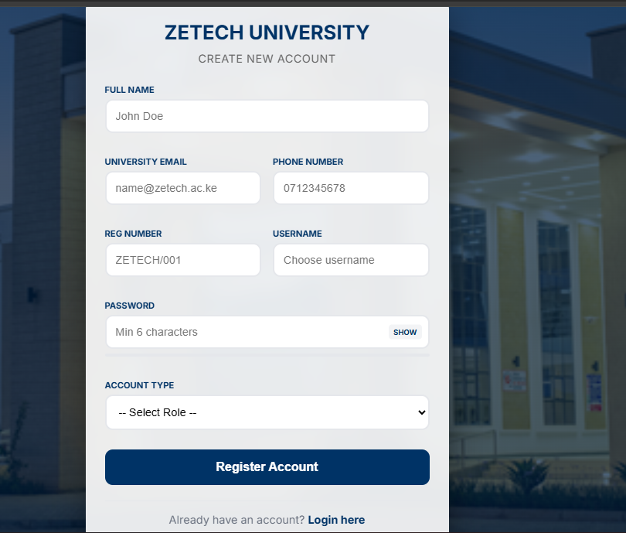
Figure 3.2.7: Signup page screenshot

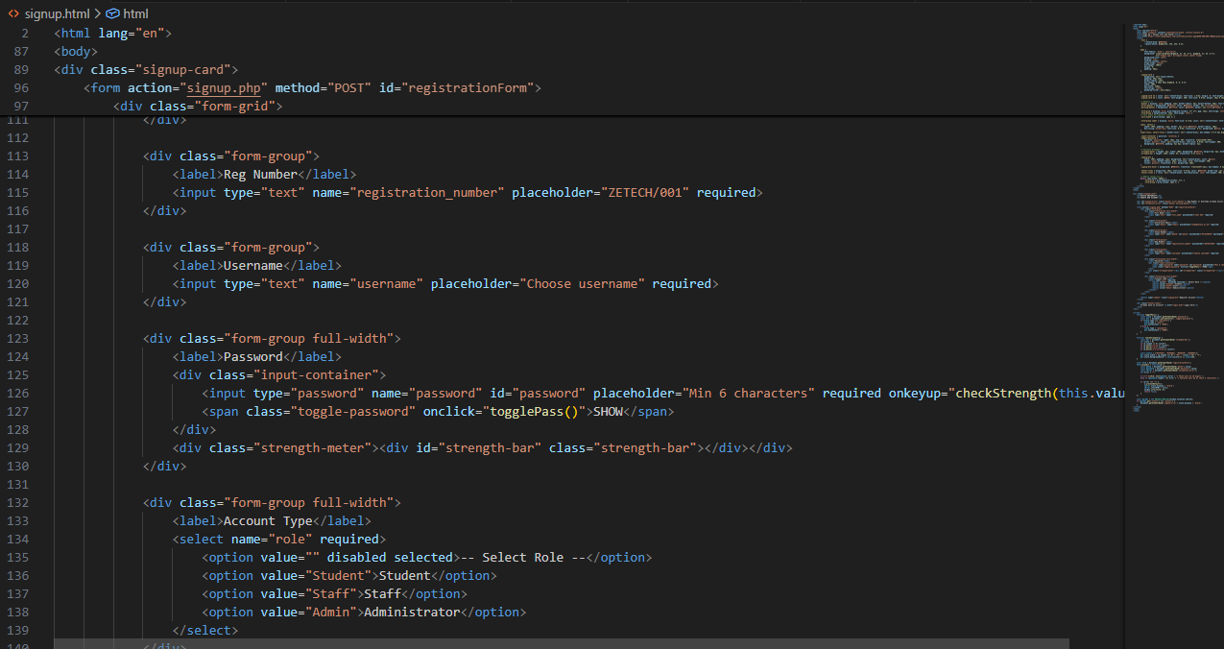
Figure 3.2.8: Signup page HTML/CSS

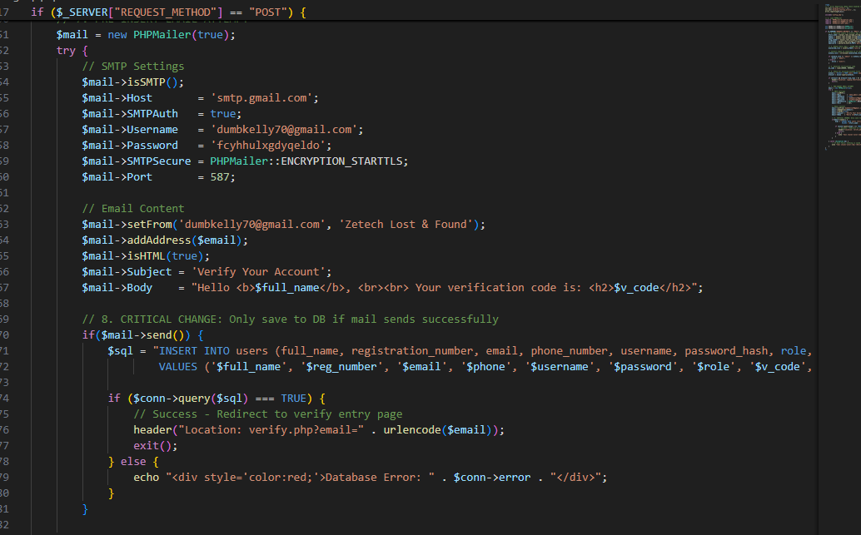
Figure 3.2.9: signup page php screenshot

3.3 Logic Development
The logic side handles the backend processing of data, including user authentication and database management. The system uses SQL queries to compare the category and location of newly reported found items with existing lost item records in the database. When a match is detected, the system automatically generates a notification to inform the potential owner. If a match is found, the system triggers a notification row in the database.

3.3.1 Database Implementation
The system utilizes a MySQL database to store user and item records. The user table was successfully implemented with fields for registration number, full name, email, phone, password hash, and role.
CREATE TABLE items (
id INT AUTO_INCREMENT PRIMARY KEY,
item_name VARCHAR(100) NOT NULL,
category VARCHAR(50),
location_found VARCHAR(100),
date_reported DATE,
status VARCHAR(20),
reported_by VARCHAR(20)
);
CREATE TABLE users (
reg_no VARCHAR(20) PRIMARY KEY,
full_name VARCHAR(100),
email VARCHAR(100),
phone VARCHAR(20),
password_hash VARCHAR(255),
role ENUM('Admin','User')
);

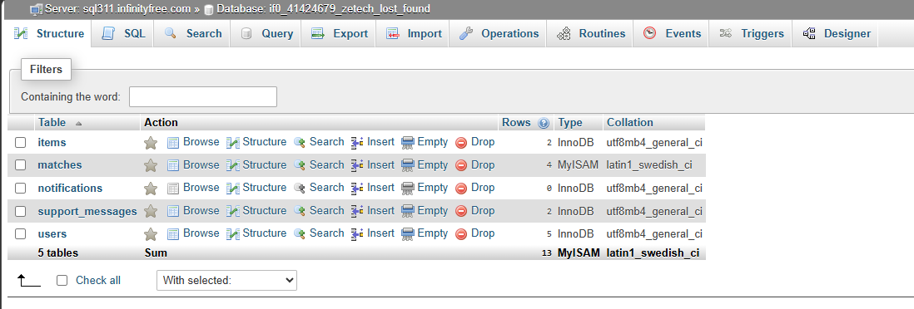
Figure 3.3.0: Database record screenshot

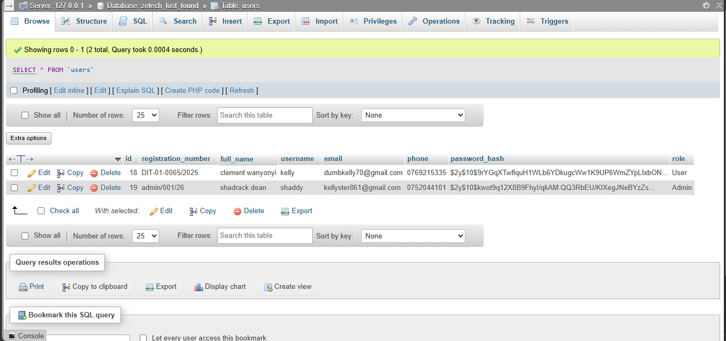
Figure 3.3.1: Database Record sample data Screenshot

3.3.2 Login Validation and Role Management
PHP scripts were developed to validate user credentials against the database. The system also includes role-based access control, allowing for 'Admin' and 'User' roles.

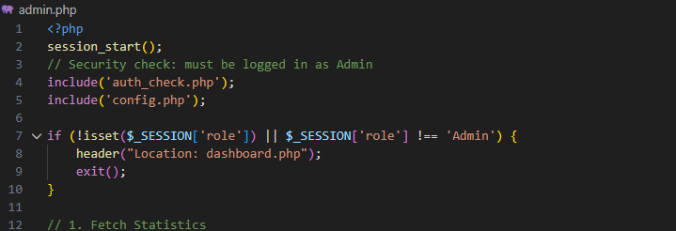Figure 3.3.2: Administrative Role Validation Logic.

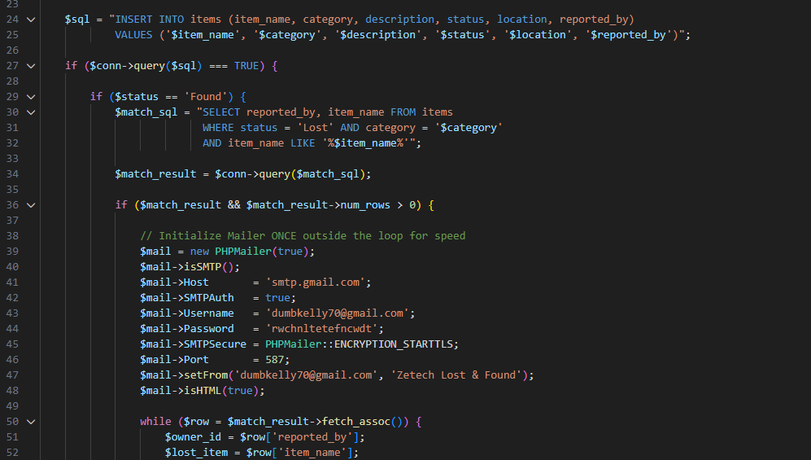Figure 3.3.3: Item Matching and Notification Logic.

3.3.4 Session Time Out Implementation
To protect student privacy, especially on shared library computers, a 15-minute inactivity timer was implemented to automatically destroy the session.
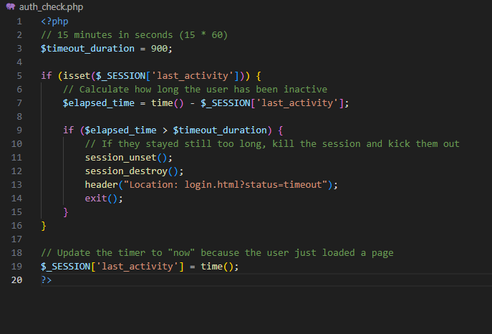
Figure 3.3.4: Session Timeout and Security Implementation

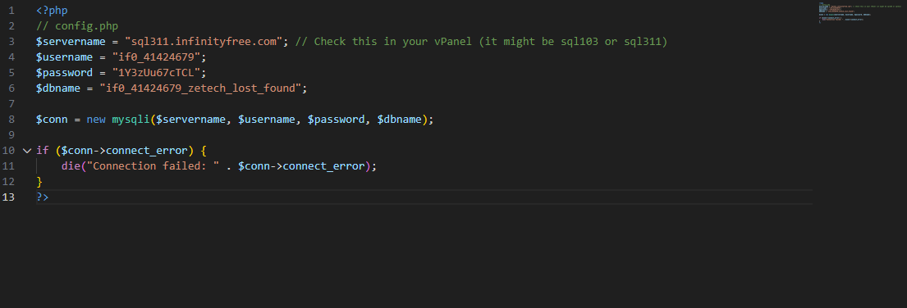 Figure3.3.5: Database Connection Configuration.

3.4 Testing
Testing was conducted in phases to ensure all functional requirements were met:
- Unit Testing: Individual PHP scripts (like report item.php) were tested to ensure data is correctly saved to the MySQL database.
- Security Testing: Verified that the password_hash() function correctly encrypts user passwords before storing them in the database and that unauthorized users cannot access the admin panel.
- Database Verification: As seen in the system logs, SQL queries were tested to ensure roles were assigned correctly, even addressing warnings such as "Data truncated for column 'role'" to ensure data integrity.
- Overall, testing confirmed that the system functions correctly, meets user requirements, and is secure against common threats such as unauthorized access and SQL injection.

Test Case | Input | Expected Result | Actual Result | Status
Invalid Login | Wrong Reg No/Pass | Show error message | As expected, | Pass
Password Visibility | Click eye icon | Toggle password visibility | As expected, | Pass
Forgot Password | Click 'Forgot Password' | Redirect to reset page | As expected, | Pass
Role Assignment | Assign 'Admin' to user | User gains admin access | As expected, | Pass
SQL Injection | Enter ' OR '1'='1 | Block login attempt | As expected, | Pass

3.5 Deployment
The system was prepared for deployment to allow stakeholders to access the platform.
- Local Server: During development, XAMPP was used as the local server environment to host the PHP files and MySQL database.
- Online Hosting: The frontend components can be hosted on platforms such as Infinityfree or GitHub Pages. However, the full system requires a web server that supports PHP and MySQL, such as Apache servers provided through shared hosting or cloud hosting services., while the full LAMP stack can be deployed to a cloud server or shared hosting provider supporting PHP and MySQL.

CHAPTER FOUR: CONCLUSION AND RECOMMENDATION

4.1 Conclusion

This project successfully developed a Campus Lost and Found Management System to improve item recovery and record management at Zetech University. Chapter One discussed the problem and objectives of the system. Chapter Two presented system design and modelling, while Chapter Three explained system development, testing, and deployment.
The system has improved efficiency by automating item reporting, tracking, and notification processes. It has also enhanced transparency and accountability through proper record management.
During the development process, several skills were acquired, including web development, database management, and system testing. Challenges faced included debugging errors, database design issues, and integrating system components, but these were successfully resolved.

4.2 Recommendation

Future improvements can be made to enhance the system further. Developers can integrate SMS or email notification systems to improve communication with users. Integration with mobile applications would also increase accessibility. Additionally, advanced technologies such as barcode scanning or QR codes can be implemented to simplify item identification and verification. Biometric verification can also be introduced to improve security. The system can also be upgraded to use cloud-based databases for better scalability and data security. These improvements would make the system more efficient, secure, and user-friendly.

REFERENCES

- Kariuki, J., & Mugo, P. (2023). Digital systems in campus management. Nairobi: Tech Press.
- Otieno, A. (2022). Improving service delivery through automation. Journal of Information Systems, 12(2), 45–60.
- Wambui, S., & Njoroge, T. (2024). Data protection practices in institutions. Nairobi: Academic Publishers.
- OpenAI. (2026). ChatGPT conversation on system development. https://chat.openai.com/
- Sommerville, I. (2016). Software engineering (10th ed.). Pearson Education Limited.
- Pressman, R. S., & Maxim, B. R. (2020). Software engineering: A practitioner's approach (9th ed.). McGraw-Hill Education.

